# Create the data for the chart

> Runs <- c(778, 678, 567, 789, 697)

> Players <- c('Rohit Sharma', 'Virat Kohli', 'S Gill', 'Ishan Kishan', 'SKY')

> # Plot the simple bar chart

> barplot(Runs, names.arg = Players, xlab = 'Players', ylab = 'Runs', main = "CricStat")

> # Plot the coloured bar chart

> barplot(Runs, names.arg = Players, xlab = 'Players', ylab = 'Runs', main = "CricStat", col = 'Green')

> # Plot the horizontal bar chart

> barplot(Runs, names.arg = Players, xlab = 'Players', ylab = 'Runs', main = "CricStat", col = 'Green', horiz = TRUE)

> # Plot the bar chart with data labels on top of each bar

> barplot(Runs, names.arg = Players, xlab = 'Players', ylab = 'Runs', main = "CricStat", col = 'Green', horiz = TRUE, cex.main = 1.5, cex.lab = 1.2, cex.axis = 1.1)

> # Add data labels on top of each bar

> text(x = barplot(Runs, names.arg = Players, col = 'Green', ylim = c(0, max(Runs)*1.2)), y = Runs + 1, labels = Runs, pos = 3, cex = 1.2, col = 'Red')

>

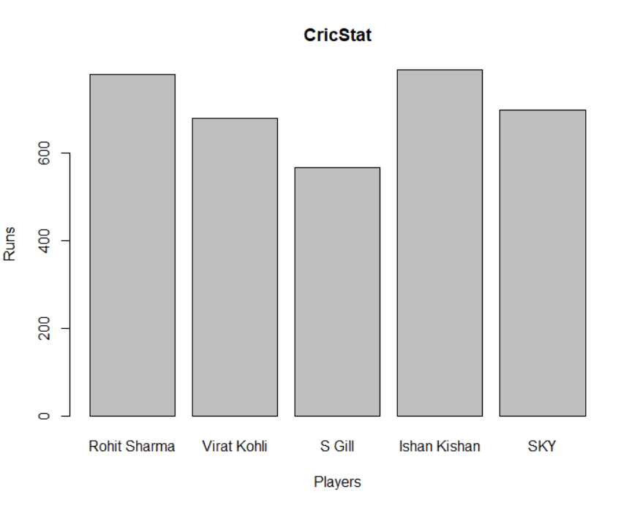 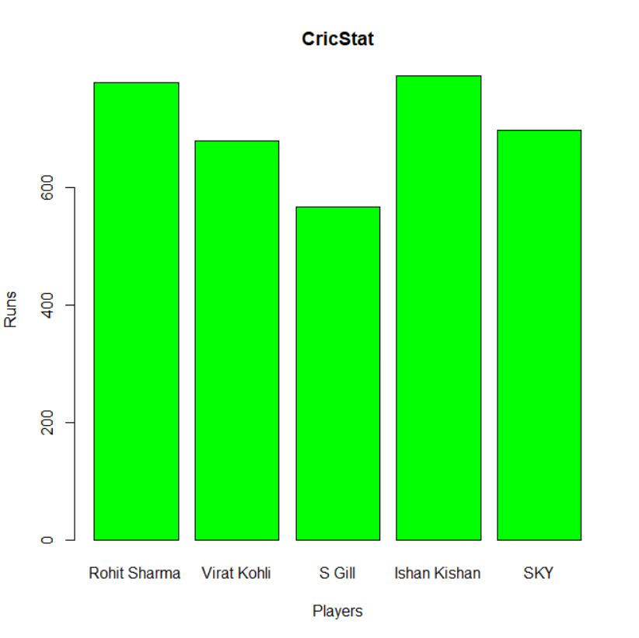

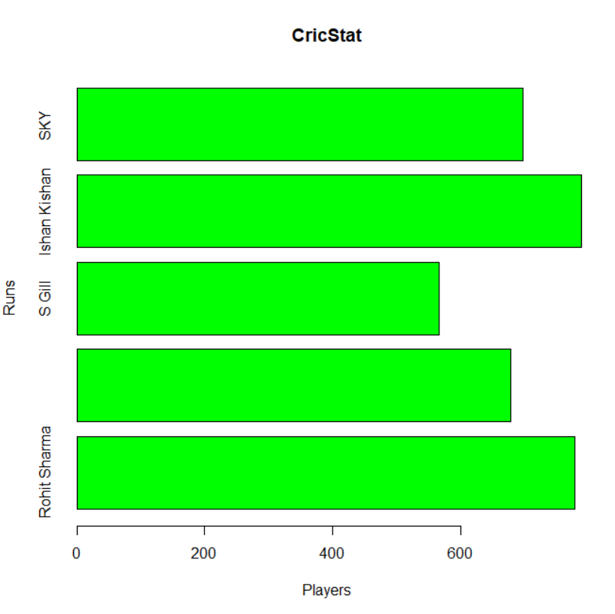 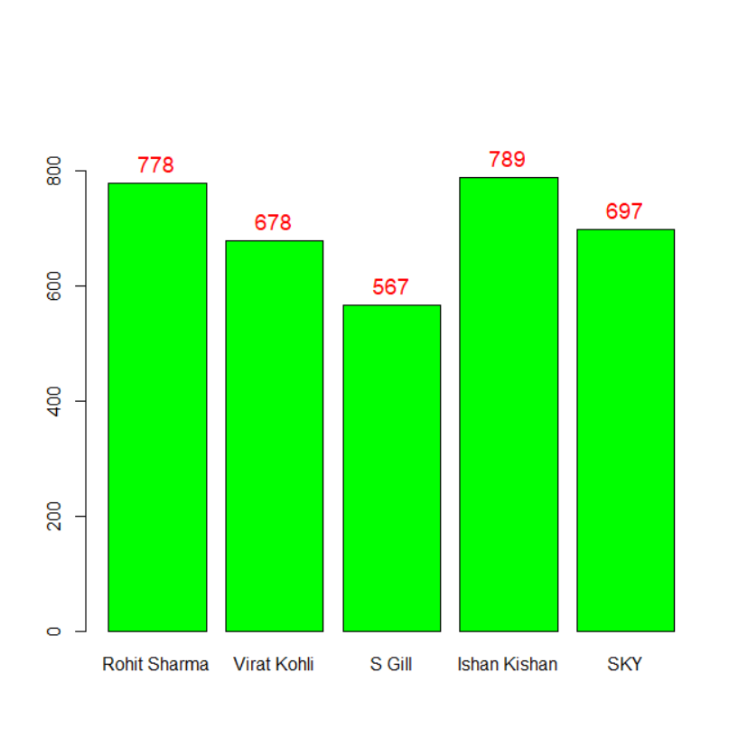

=========================================================🡺 Line Chart Visualization

# Create the data for the Line Chart.

> v <- c(34, 45, 38, 26, 42)

> # Plot the Line Chart.

> plot(v, type = "o", col = "green", xlab = "Month", ylab = "Production", main = "Monthly Production chart")

=====================================================🡺 Histogram Chart Visualization

> # Create data for the histogram.

> v <- c(19, 23, 11, 5, 16, 21, 32, 14, 19, 27, 39)

> # Create the histogram.

> hist(v, xlab = "No.of Articles ",col = "green", border = "black")

===================================================🡺 Horizontal bar Chart Visualization

> # Horizontal Bar Plot for Ozone concentration in air

> barplot(airqualityOzone, main = 'Ozone Concentration in air', xlab = 'ozone levels', horiz = TRUE)

==========================================================🡺 Box Plot Visualization

> # Multiple Box plots, each representing an Air Quality Parameter

> boxplot(airquality[, 0:4], main ='Box Plots for Air Quality Parameters')

